**Web Programming**

Lab - 13

React

Name: Sushen Grover

Reg No: 23BCE1728

Slot: L11+L12+L31+L32

Class No: CH2024250502774

Course Code: BCSE203E

Faculty: Dr. L.M. Jenila Livingston

Question:

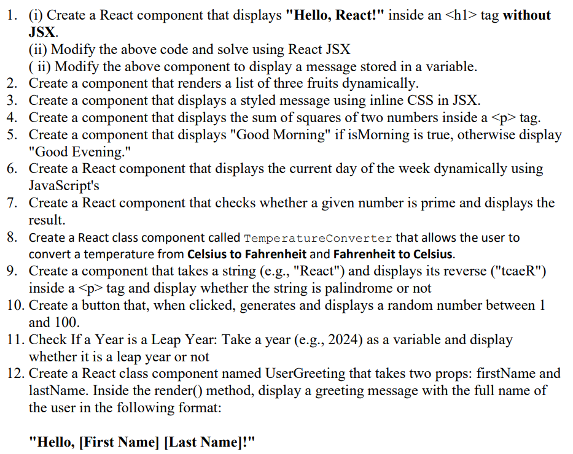

Code:

JSXComponents.js

import React, { Component, useState } from "react";

// 1. React component without JSX

const WithoutJSX = () => {

  return React.createElement("h1", null, "Hello, React!");

};

// 1. React component with JSX

const WithJSX = () => <h1>Hello, React!</h1>;

// 1. React component displaying a variable message

const MessageComponent = () => {

  const message = "Welcome to React!";

  return <h1>{message}</h1>;

};

// 2. List of fruits dynamically

const FruitList = () => {

  const fruits = ["Apple", "Banana", "Cherry"];

  return (

    <ul>

      {fruits.map((fruit, index) => (

        <li key={index}>{fruit}</li>

      ))}

    </ul>

  );

};

// 3. Styled message using inline CSS

const StyledMessage = () => {

  const style = { color: "blue", fontSize: "20px" };

  return <p style={style}>This is a styled message.</p>;

};

// 4. Sum of squares of two numbers

const SumOfSquares = ({ a, b }) => {

  return <p>Sum of squares: {a * a + b * b}</p>;

};

// 5. Conditional rendering based on isMorning

const Greeting = ({ isMorning }) => {

  return <h1>{isMorning ? "Good Morning" : "Good Evening"}</h1>;

};

// 6. Display current day

const CurrentDay = () => {

  const days = ["Sunday", "Monday", "Tuesday", "Wednesday", "Thursday", "Friday", "Saturday"];

  const today = new Date().getDay();

  return <p>Today is {days[today]}</p>;

};

// 7. Check if a number is prime

const PrimeCheck = ({ num }) => {

  const isPrime = (n) => {

    if (n < 2) return false;

    for (let i = 2; i < n; i++) {

      if (n % i === 0) return false;

    }

    return true;

  };

  return <p>{num} is {isPrime(num) ? "a prime number" : "not a prime number"}.</p>;

};

// 8. Temperature Converter (Class Component)

class TemperatureConverter extends Component {

  constructor(props) {

    super(props);

    this.state = { temp: "", result: "" };

  }

  convertToFahrenheit = () => {

    this.setState({ result: (this.state.temp * 9) / 5 + 32 });

  };

  convertToCelsius = () => {

    this.setState({ result: ((this.state.temp - 32) * 5) / 9 });

  };

  handleChange = (e) => {

    this.setState({ temp: e.target.value });

  };

  render() {

    return (

      <div>

        <input type="number" value={this.state.temp} onChange={this.handleChange} />

        <button onClick={this.convertToFahrenheit}>To Fahrenheit</button>

        <button onClick={this.convertToCelsius}>To Celsius</button>

        <p>Converted Temperature: {this.state.result}</p>

      </div>

    );

  }

}

// 9. Reverse a string and check palindrome

const StringManipulation = ({ text }) => {

  const reversed = text.split("").reverse().join("");

  const isPalindrome = text === reversed;

  return (

    <p>

      Reverse: {reversed} <br /> Palindrome: {isPalindrome ? "Yes" : "No"}

    </p>

  );

};

// 10. Generate random number on button click

const RandomNumber = () => {

  const [number, setNumber] = useState(null);

  return (

    <div>

      <button onClick={() => setNumber(Math.floor(Math.random() * 100) + 1)}>

        Generate Random Number

      </button>

      {number !== null && <p>Random Number: {number}</p>}

    </div>

  );

};

// 11. Check leap year

const LeapYearCheck = ({ year }) => {

  const isLeap = (year % 4 === 0 && year % 100 !== 0) || year % 400 === 0;

  return <p>{year} is {isLeap ? "a Leap Year" : "not a Leap Year"}.</p>;

};

// 12. UserGreeting component (Class Component)

class UserGreeting extends Component {

  render() {

    return <h1>Hello, {this.props.firstName} {this.props.lastName}!</h1>;

  }

}

export {

  WithoutJSX,

  WithJSX,

  MessageComponent,

  FruitList,

  StyledMessage,

  SumOfSquares,

  Greeting,

  CurrentDay,

  PrimeCheck,

  TemperatureConverter,

  StringManipulation,

  RandomNumber,

  LeapYearCheck,

  UserGreeting,

};

App.js

import React from "react";

import { WithJSX, MessageComponent, FruitList, StyledMessage, SumOfSquares, Greeting, CurrentDay, PrimeCheck, TemperatureConverter, StringManipulation, RandomNumber, LeapYearCheck, UserGreeting } from "./JSXComponents";

function App() {

  return (

    <div>

      <WithJSX />

      <MessageComponent />

      <FruitList />

      <StyledMessage />

      <SumOfSquares a={3} b={4} />

      <Greeting isMorning={true} />

      <CurrentDay />

      <PrimeCheck num={7} />

      <TemperatureConverter />

      <StringManipulation text="React" />

      <RandomNumber />

      <LeapYearCheck year={2024} />

      <UserGreeting firstName="Sushen" lastName="Grover" />

    </div>

  );

}

export default App;

Output:

